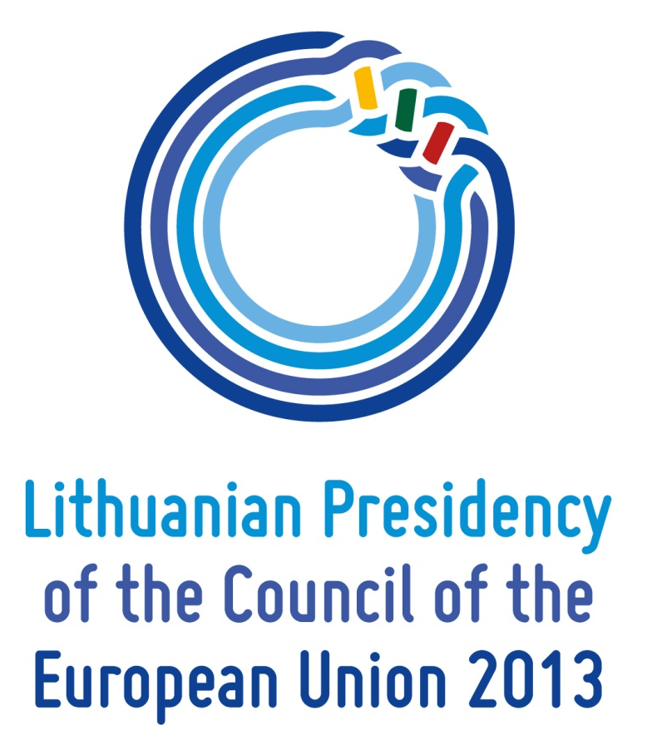

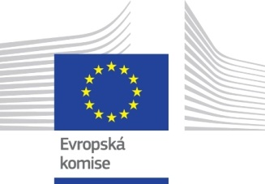

Invitation
Discussion
External policy priorities of the Lithuanian EU Council Presidency 2013

European House, Jungmannova 24, Prague 1
2 July 2013,
10.00 – 12.00

Moderator: Tomáš Weiss, Head of Department of West European Studies, Faculty of Social Sciences, Charles University in Prague

Presentation of Lithuanian Presidency priorities: Mr. Aurimas Taurantas, Ambassador of Lithuania in the Czech Republic

Speakers:
Mr. Jan Bauer, Chairman of the European Affairs Committee, Chamber of Deputies of the Parliament of the Czech Republic (tbc)
Mr. Jiři Schneider, First Deputy Minister of Foreign Affairs of the Czech Republic
Mr. Jan Michal, Head of the Representation of the European Commission in the Czech Republic

Commentators:
Mr. Petr Patočka, Glopolis
Mr. Jakub Janda, Evropské hotnoty

(The discussion will be held in English and Czech with simultaneous interpretation)

R.S.V.P. before 1 July, 2013
to comm-rep-cz@ec.europa.eu or vaida.nemeckova@urm.lt

Programme

Lithuania is the first Baltic state to hold the EU Council Presidency. Twenty-three years after restoring its independence and returning to the European family, Lithuania will use the opportunity to work for the benefit of all EU member states. Lithuanian Presidency will focus on the three main priorities of a credible, growing and open Europe. The three categories being closely interconnected, the Open Europe pillar, however, is designated to be in the focus of this debate.

EU Enlargement process: what new questions does the end and the beginning of the process bring up? What comes after Croatia? What is the prospect and the timeline for the other accession countries as well as the biggest challenges?

EU Eastern Partnership, before the Vilnius Summit and after: what should the Vilnius EaP Summit aim to achieve? What should be the priorities going forward after Vilnius? Reflection on dynamics of the EU neighborhood policy‘s „eastern vector“ throughout the period since the Prague EaP Summit 2009, through Warsaw 2011, till now.

Free trade with EU neighboring countries and strategic partners vs smarter control of the EU’s external borders: what challenges we face in finding the right balance between the EU’s determination to promote free, fair and open trade, ensuring the smooth travelling and preventing smuggling and other illicit trade, illegal migration, human trafficking?

Energy security tasks. With energy import dependence growing throughout the EU, international and geopolitical issues are of over growing importance. How much the energy security requires the EU to come together to diversify import routs, sources and suppliers, particularly for gas supply? Enhancing synergy among CSDP, CFSP and Common Energy Policy will be one of the main priorities in the run up to the European Council in December.

Discussion on the 2013 European External Action Service Review: what opportunities, challenges and possible approaches does it contain?

