European Parliament elections 2014 - Preliminary Analysis

Final Results European Parliament (EP) elections 2014 - Change from 2009

2009 2014
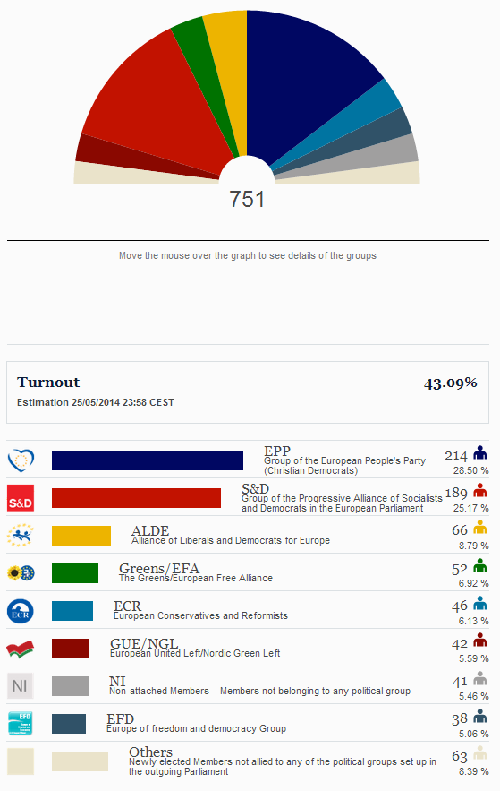
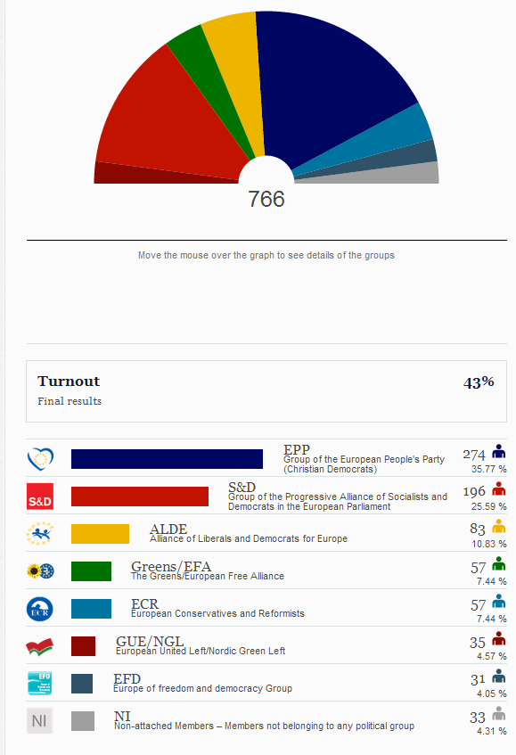

Source: http://www.results-elections2014.eu/en/election-results-2014.html

The main changes between the 2009 and 2014 European Parliaments will be the reductions of the EPP’s lead, with a loss of 60 seats, compared to only 2 seats lost for S&D. The rise of Eurosceptics and far right parties can be seen in the greater number of seats for NI parties and other parties.

However, in terms of the way Parliament functions and passes legislature, it will still rely on a broad coalition between the EPP and S&D to create the majority needed to pass bills. When it comes to appointing the new President of the Commission, both parties are still horse-trading, to get enough votes to appoint their candidate.

How have party seats changed from 2009?

All the major parties lost seats, as the rise of NI (non-attached parties) took their votes. Most of these parties are far right and extremist parties that do not fit the traditional party groupings in the EP. Below some examples:

- Italy and Hungary : the only 2 examples where parties at the government have got good results [PD / Matteo Renzi] for Italy and [Fidesz / Viktor Orban] for Hungary
- France saw a victory for the far right Front National party, who received 25% of the vote
- Similarly, in the UK, UKIP won with 32% of the vote, giving Eurosceptics a far louder voice in the Parliament
- In Sweden and Greece, left wing parties won the most votes over the incumbent Conservative parties.

Source: http://www.bbc.co.uk/news/events/vote2014/eu-election-results

S&D: gained seats in Italy, Germany, UK, Romania, Bulgaria and Portugal

EPP: suffered their biggest losses in France, Germany, Czech Republic and Spain

ALDE: suffered losses in the UK, Czech Republic, Italy and Poland

Currently, S&D have been most open about where they have made the most gains and losses. We will have a clearer picture of this as more results come in. In the meantime, if you have more information about your national situation, please feel free to share it with us so we can update the document. Please send the info to James at James.Philpot@concordeurope.org.

Graph on wins and losses, which is still being updated:

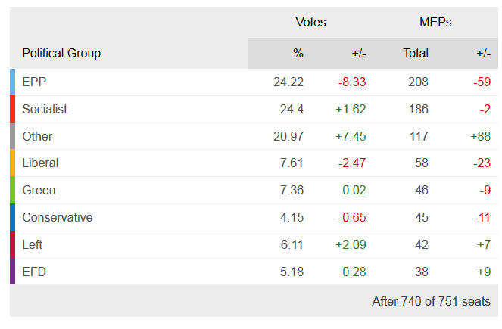
Source: http://www.bbc.co.uk/news/events/vote2014/eu-election-results

Turnout

Turnout at the European Parliament elections this year was marginally better than in 2009, improving from 43% to 43.09%, which whilst not a significant difference in terms of actual voters, is important as this is the first time that turnout has actually increased. The highest turnout was in Belgium and the Netherlands, who had 90%, whilst the lowest was in Slovakia, with 13%

http://www.results-elections2014.eu/en/turnout.html

This infographic shows the level of turnout across all the participating countries.
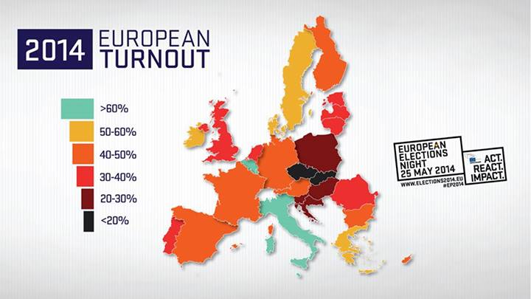

Below please find a graph, which we developed for you showing the changes in the turnout in 2009 in comparison to 2014 for some EU Member States.

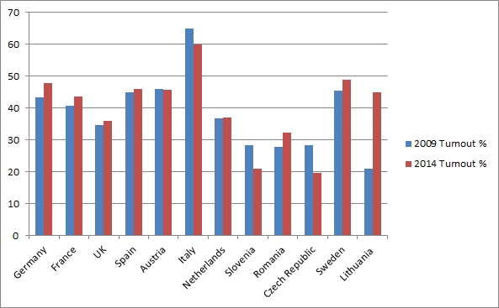

Most countries’ turnout was marginally improved, although some did see significant reductions in turnout, such as Cyprus, the Czech Republic and Latvia, who saw reductions of 16%, 9% and 23% respectively.

http://www.results-elections2014.eu/en/election-results-2009.html

List of newly elected MEPs

Here you can find two resources that list the new MEP’s (still being updated):

http://ep2014.org/

https://www.theparliamentmagazine.eu/articles/news/european-elections-mep-lists-country-country

Gender Balance in the European Parliament

The EP has been steadily improving its record on female representation, with a consistent increase in the number of female MEP’s, of which the percentage has more than doubled since 1979. The newly elected number won’t be known until the first plenary session on 1st July. You can check again this link after the 1 July for the new EP. However, gender parity is not to be expected.
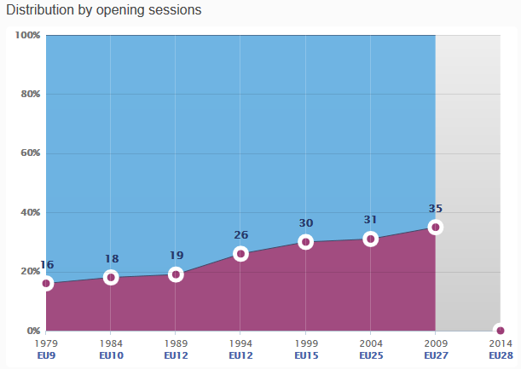

Source: http://www.results-elections2014.eu/en/gender-balance.html

Here, you can find an infographic that gives information on the female MEPs in the previous Parliament.

Source: http://www.repubblica.it/static/speciale/2014/elezioni/europee/distribuzione_seggi2009.html

Far Right/Eurosceptic % of Vote

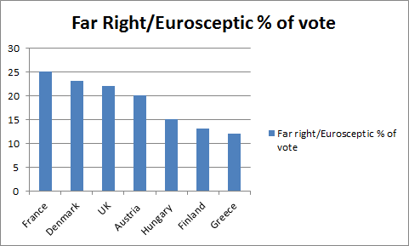

Some (re-) elected MEPs who have been championing our issues on development, human rights and/or gender equality

Please note that this is just a first rough selection. We will soon send you a tool to help us properly mapping the members of the New European Parliament.

Charles Goerens LUX ALDE re-elected (PCD champion)
Eva Joly FR GREENS re-elected (was chair of Deve secretariat)
Norbert Neusser, DE, S&D re-elected (Development champion, ACP)
Richard Howitt (Labour), UK re-elected (Development, HR champion)
Bart Staes (Groen), Belgium DEVE substitute re-elected (Development champion)
Franziska Keller, DE, GREENS re-elected (Development champion)
Mikael GUSTAFFSSON SE GUE (ex FEMM chair, gender equality champion)
Barbara Matera IT EPP elected (opinion on EYD2015 Report)
Soraya Post SE newly elected feminist (from Sweden Feminist Initiative)
Mercedes Bresso IT S&D former president of CoR and supporter of EYD2015
Cecile Kyenge IT S&D former IT minister of Integration
Heidi Hautala (VIHR), Finland (was MEP (co-chair of the sub-committee on HR beginning of the last mandate but went into national politics, now re-elected)
Jean Lambert UK re-elected (Development, Gender, HR champion)

Quotes and Tweets from the Presidency Candidates

"I want to be the next president but that does not mean I am not prepared to compromise" - Jean-Claude Juncker

"I feel fully entitled to become the next head of the commission and believe I have a real chance" - Martin Schulz

“The new parliament has to prove that it takes the obligation of the Lisbon Treaty, namely Policy Coherence for Development, seriously. Until now, especially the two big groups have often not stuck to their rhetoric on development when they voted on the "hard" issues like trade agreements or the CAP reform. I hope they will deliver on their promises now.” - Franziska Keller

“A new chapter begins--with greater strength, we are energized to change Europe!” Alexis Tsipras (Twitter)

Key quotes we received until now from supportive newly elected MEPs.

We asked several of the champions to provide us with their interpretation of the results and what kind of implications it could have on development policies. Until now we only received one feedback. We will add the others soon.

“I am very happy about the great result of the German SPD - which is at the same time a fantastic success for our top candidate Martin Schulz. The people went to the polls and want a Europe of fairness and social justice, which is what we stand for. At the same time, also this became a reality in the European Parliament: About 17 per cent of the seats will be allocated to the right-conservative or right-wing populist camp. Another eight or nine per cent come from very diverse splinter parties. That will not really facilitate our business, particularly not in the field of development policies.” Norbert Neuser

Interesting media articles

http://blogs.lse.ac.uk/europpblog/2014/05/26/european-parliament-election-results-our-experts-react/

http://www.euractiv.com/sections/eu-elections-2014/europe-course-grand-coalition-after-election-302386

http://www.euronews.com/2014/05/23/european-elections-2014-live-coverage-results-and-reactions-/

Statement by the outgoing President of the Commission: http://europa.eu/rapid/press-release_STATEMENT-14-171_en.htm

