Fact Sheet
Magyar Máltai Szeretetszolgálat (MMSZ)
Hungarian Charity Service of the Order of Malta (HCSM)

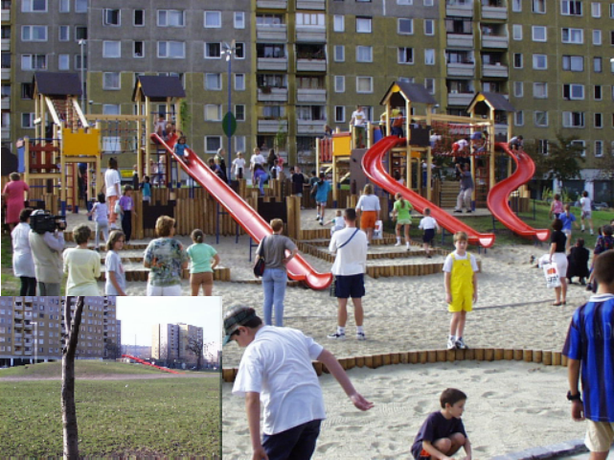
HCSM playground
in a low-income housing estate
Background.
The MMSz was founded in 1989, the first national NGO dedicated to humanitarian relief and the service of the poor within Hungary and in neighbouring countries, at the time of the collapse of the socialist regimes in the region. It is affiliated with the Order of Malta (SMOM) and with Malteser International. Today it is one of the largest non-governmental humanitarian and social development organizations in Hungary. It has an annual budget of over 5 billion HUF (about 17 million Euros), and it employs about 1,000 salaried workers and over 8,000 volunteers. It derives half of its income from Government subsidies, and a further 30% from private donations.
Since its foundation, our Organization has developed and used exemplary, participatory and human rights-based models in the field of social work and health care. Some of our models have been incorporated into the national social/healthcare system (for example: home care alert system, homeless care). We are regularly requested by the Government of Hungary for policy advice on these issues.

One of our strong points is our experience with volunteers. We have extensive experience in:
- recruiting, training and managing local volunteers for local assignments;
- screening and training local volunteers for postings abroad;
- hosting and managing international volunteers.
We participate actively in the EVS programme.

Currently in Hungary the HCSM works in the following fields:

Health Care Services:
24/7 medical (GP) posts; mobile screening; EMS and ambulance service; medical centres.

Disaster relief:

Planning and coordination of post-rescue care services, distribution of donations, management of temporary shelters and of resettlement, medical care and psychosocial support to survivors

Disabled Care: day care; disabled support services.

Child and family care:
Playgrounds, playhouses; family care units; family support; youth clubs; integrated mother-baby, child, youth and elderly day centres.

Homeless care: Homeless care units; street support; mobile medical care.

Elderly care: Home care service; elderly people’s homes; day care homes and elderly people’s clubs.

Other Services:
Integrated local development models in disadvantaged communities; soup kitchens; rental and repair of medical aids; legal support for indebted families; food distribution; rural support services.

Education: School for Social Care and Nursing .

Humanitarian, disaster relief activities

The HCSM has acquired significant experience and knowledge in the field of humanitarian and disaster relief, both within Hungary and abroad. In its beginnings, HCSM helped East German refugees, and organized relief actions in Romania and Yugoslavia; recently, we participated in the selection of Libyan wounded for treatment in Hungary under an EU joint initiative, and assisted Syrian refugees in Jordan with medical supplies. HCMS recently established the Hungarian Maltese International Medical Rescue Team, to heighten its preparedness for international disaster situations; this team involves itself also in ongoing relevant local activities, such as medical screening of the Roma population and of the poorest population groups.

The HCMS’s role in humanitarian activities is the planning, implementation and coordination of post-rescue care and relief, and medical/psychosocial treatment. Our niche capability is short term, high intensity support to the people in need, using our trained human resources.

International activity of the MMSZ
HCMS’s primary focus is on activities in Hungary and around Hungary, and our current funding is almost totally earmarked for national activities. However, we believe that we have accumulated considerable experience, know-how and regional knowledge, which can be used outside Hungary for the benefit of all people in need. It is our duty to pass on our corporate knowledge. We ourselves received much outside support in the past, especially at the time that our Organization was founded: that is why we are inspired to take part in international development and relief projects.
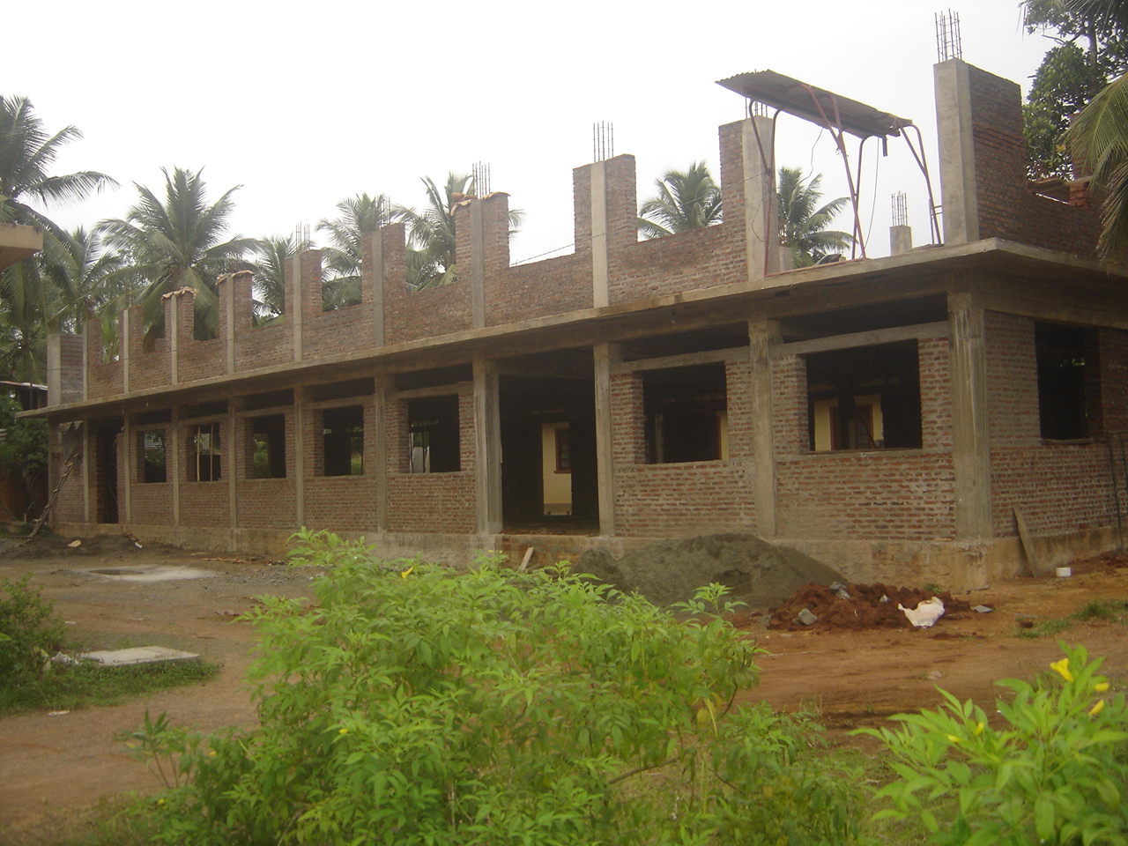
Building a pre-school in Sri Lanka

Some of our recent international projects are:
- Educational Program, “Golden hour of the patient”, Ukraine 2012
- Mobile Medical Screening Center donation, Ukraine 2011
- Kindergarten construction, Sri Lanka, 2010-2012
- Drinking water project, Kenya, 2011-2012
- Miscellaneous medical care initiatives in Libya and Syria, 2012

We would like to expand our participation in international development and relief work, to which we can contribute our technical know-how, our regional expertise and our human resources. We are looking for partners with relevant expertise, for the purposes of joint tendering, resource mobilization, project development and implementation.

We believe that our most useful areas of expertise are the following:
- Support for families in vulnerable situations and for the homeless
- Integrated local development of disadvantaged communities
- Care of the disabled and the elderly
- Hosting and coordinating volunteer services
- Disaster relief: planning and coordination of post-rescue services; medical care and psychosocial support.
* * * * * * * * * * * *
Contact:
Magyar Máltai Szeretetszolgálat
Hungarian Charity Service of the Order of Malta
H-1125 Budapest, Szarvas G. út 58-60
mmszok@maltai.hu
adanyi.laszlo@maltai.hu

