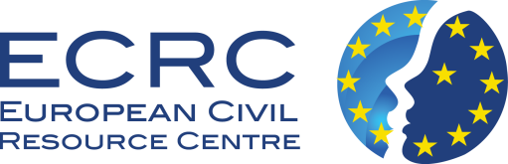
European civil resource centre
1202 Sofia, Bulgaria, 1st Pop Bogomil Str.
Tel. +359 2 442 53 66
E-mail: europe@ecrc-eu.com , web: http://ecrc-eu.com

Dear colleagues,

We are pleased to announce that on 1 June 2013 open doors European Civil Resource Centre that will provide information about the resources and opportunities offered by the “Europe for Citizens” Programme.

The main goal of the Centre is to support NGOs and local authorities in the planning and strategic management of the project cycle of the “Europe for Citizens” Programme.

All services provided by the Centre are free and related to:
- Provision of information about the conditions and mechanisms of the “Europe for Citizens” Programme and other similar Programmes of the EC;
- Provision of information, consultations, advice and technical support in the preparation of the project proposals/ideas and their realization;
- Provision of advice and consultative-methodological help with the organization of appropriate formats for exchange of information and good practices.

The main activities are directed towards:
- Creation of an international network with potential partners and beneficiaries within the “Europe for Citizen” Programme; The registration in the network is free, easy and accessible on the website of the Centre: http://ecrc-eu.com (Section “Partnership”). Each registered participant receives up-to-date information about present news and initiatives, free methodological and technical help with the preparation of the project proposals/ideas and their realization, contacts with national and international partners;

- Organization of practical trainings about presenting the “Europe for Citizens” Programme – aims, mechanisms, opportunities; development of new project proposals; presentation of good practices. The trainings are current and will take place in the period July- September 2013 in various towns in the country. The information days will be accessible to all participants in the national network.

The activities of the European Civil Resource Centre are organized with the financial support of the European Commission (The Education, Audiovisual and Culture Executive Agency), the “Europe for Citizens” Programme, Action 1 – “Active Citizens for Europe”, Measure 2.2 – “Support Measures”

You can find more information on the website of the Centre: www. ecrc-eu.com
In the Centre’s office: 1202 Sofia, 1 Pop Bogomil, floor 5, office 27
Tel.: +359 2 442 53 66, e-mail: europe@ecrc-eu.com

