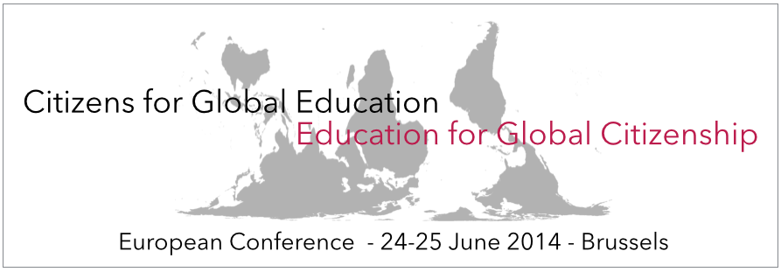

Invitation
Dear Sir, Madam
We are currently experiencing a transformative phase in global development practice as the ideas, visions, and goals of the Post2015 Framework are being reviewed. It has become clear that the Post-2015 Framework aspires to be a universal process and encompasses all areas of human development. This means that it should include a global agenda for education worldwide. And that this global agenda should be coherent with the aims of new Framework.
To ensure that the world develops sustainably, that rights of people are guaranteed and that we develop a more equitable world, our education systems need to prepare the next generations to do this. We need a Global Citizenship Education (GCE). This education exists in many continents, schools and communities in many forms and different practices. Global Citizenship Education will need to be built on all these traditions such as Education for Sustainable Development, Development Education, Global Education, Human Rights Education and Peace Education. The discussion about the Post2015 Framework therefore needs a solid proposal on Global Citizenship Education, developed by practitioners, institutions, academics and educators together.
That is why CONCORD in partnership with UNESCO, Global Campaign For Education, Oxfam International, CIVICUS, Beyond 2015, Education International, Engagement Global and the North-South Centre are organizing a European Conference on Global Citizenship Education and the Post2015 Framework.
The conference is organized in conjunction with the Replenishment Conference of the Global Partnership for Education and the High-Level meeting on Education and Post-2015 of UNESCO and UNICEF.

The conference aims at a multi-stakeholder participation and the application process has opened on 22th of April and the DEADLINE is 15 May. You can apply here:
https://docs.google.com/forms/d/1YVW10bWWAzjeyN3NiIDOnw0inoT4UEfAqt9-tUILnkc/viewform
The organizers will make a selection that balances education and Post-2015 experience, stakeholders, age, gender and geographical spread. You will be informed on Wednesday 21/5 whether you have been selected.
Please note that the conference fee is self-selected and is 25/100/250 Euro depending on whether you have an organization that supports you and your own resources. The conference fee needs to be paid in advance to secure your place at the conference. Please also take into account that while the participation fee covers lunch on 24-25 and dinner on 24, CONCORD does not cover your travel nor accommodation.
For any questions or more information, please contact Maarten Coertjens, DEEEP Advocacy Officer, Concord, maarten.coertjens@concordeurope.org or visit the conference website http://movement.deeep.org/conference-global-citizenship-education/
Looking forward to your participant and to working with you to get a strong focus on the real challenges we face in to the Post2015 Framework.
On behalf of the partners:
In support of the Global Education First Initiative.
